**Configuration Values Setup for AX**

Below image shows the set of configurations we need to get from AAD(Azure Active Directory) and AX instance.

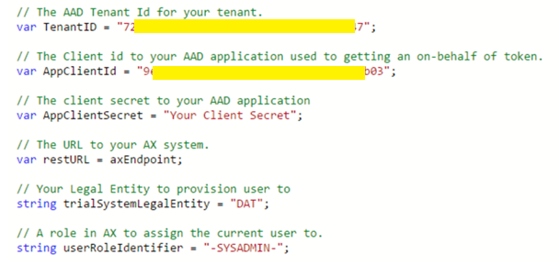

* **TenantID** :

It’s the AAD tenant id where the application is registered.

Azure Active Directory -> Properties -> Directory ID

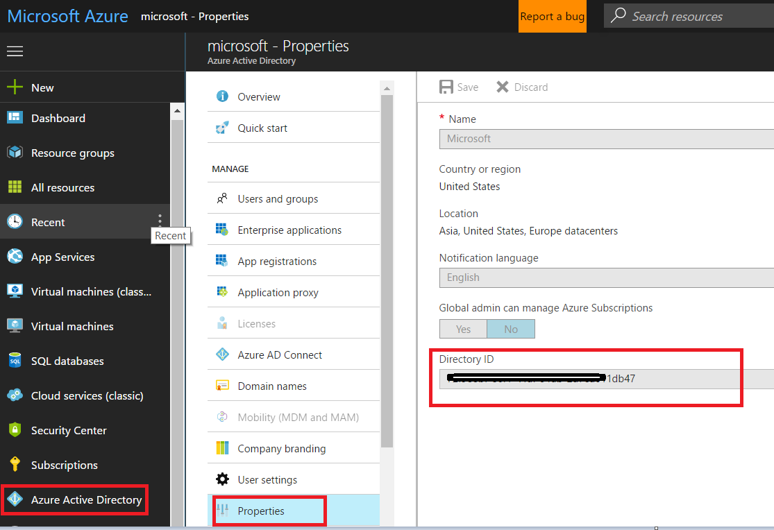

* **AppClientID:**

Your registered application ID

Azure Active Directory -> App Registrations -> Registered App -> Settings -> Application ID

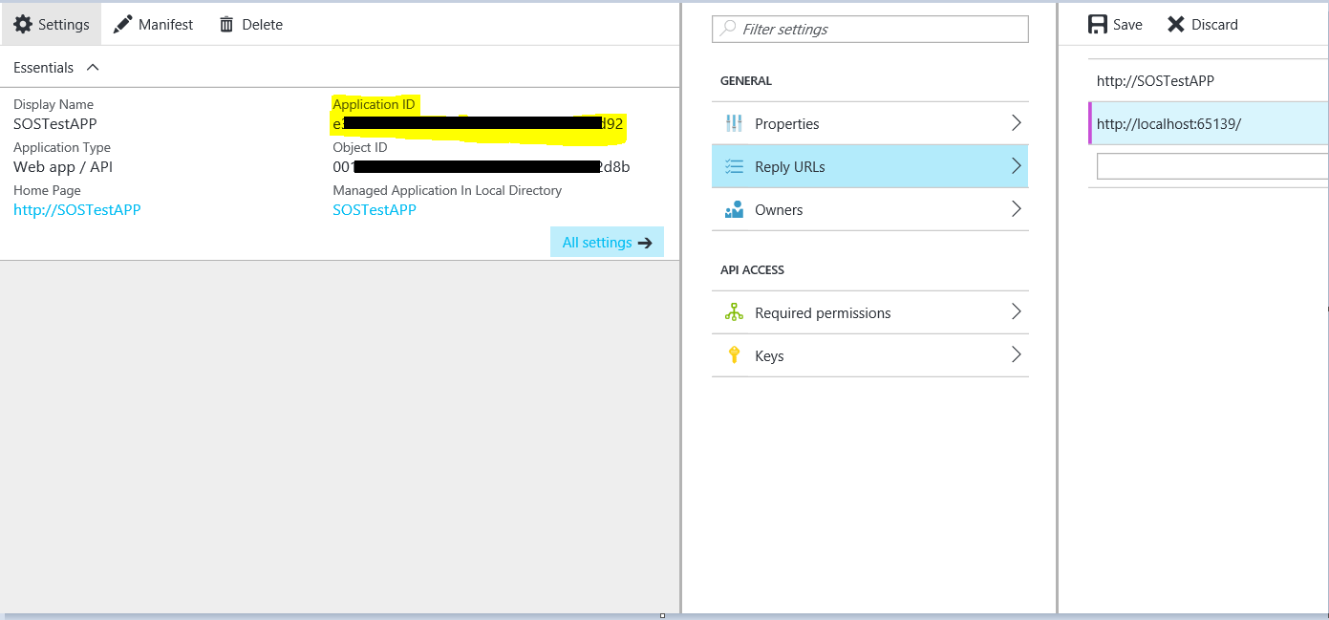

* **AppClientSecret:**

Your registered application Secret

Azure Active Directory -> App Registrations -> Registered App -> Settings -> Keys -> your newly created KEY

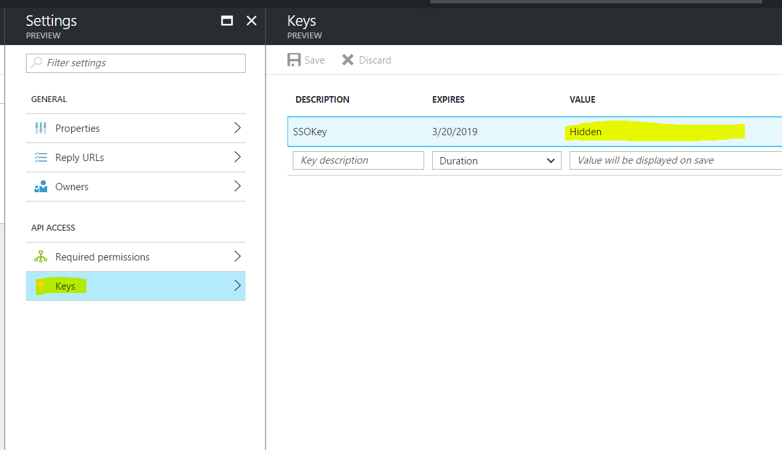

* **restURL:**

Your Ax instance URL. It looks like

<https://yourAXinstancename.cloudax.dynamics.com/>

* **trailSystemLegalEntity:**

Company to assign to User.

Ax Portal -> Navigation Pane -> Modules -> Organization administration -> legal entities

-> Your required Company -> Company

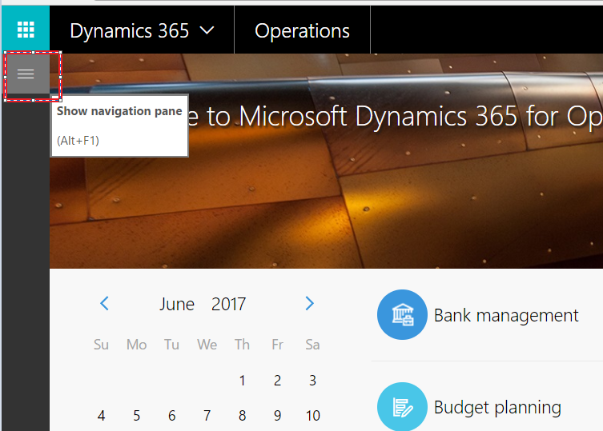

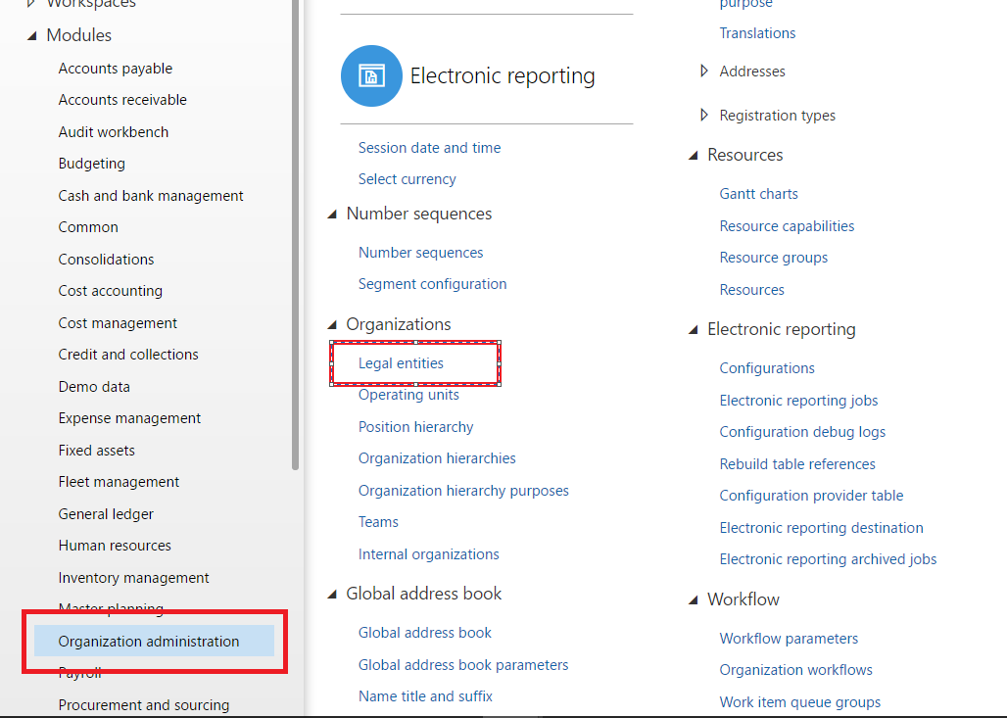

Select Existing company or Create New Company -> Company attribute

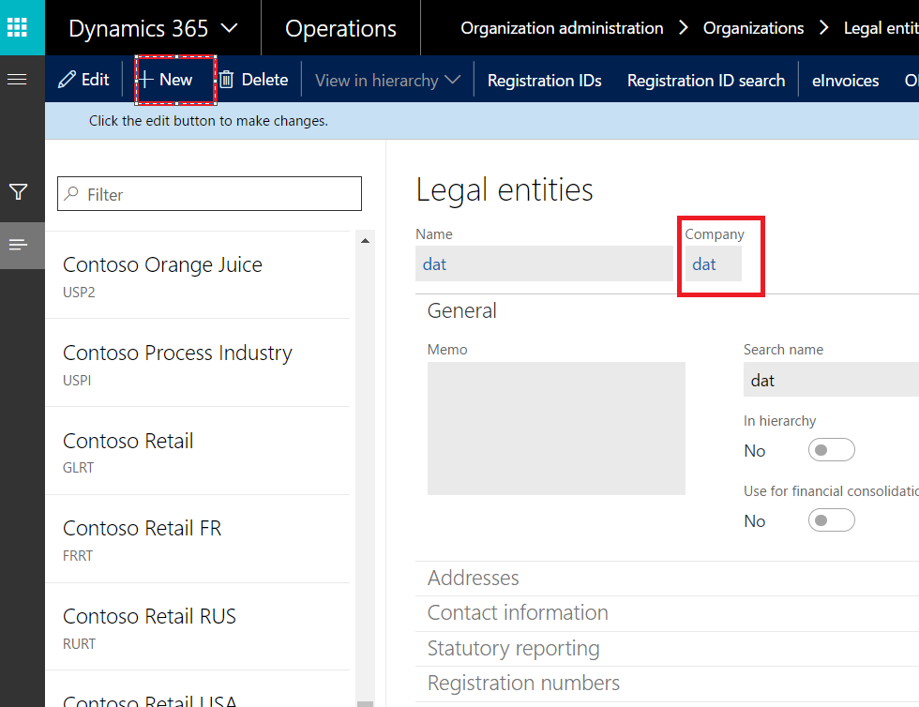

* **userRoleIdentifier:**

Role to assign to User.

Ax Portal -> Navigation Pane -> Modules -> System administration -> Security Configuration

-> Your required Role -> Aot name



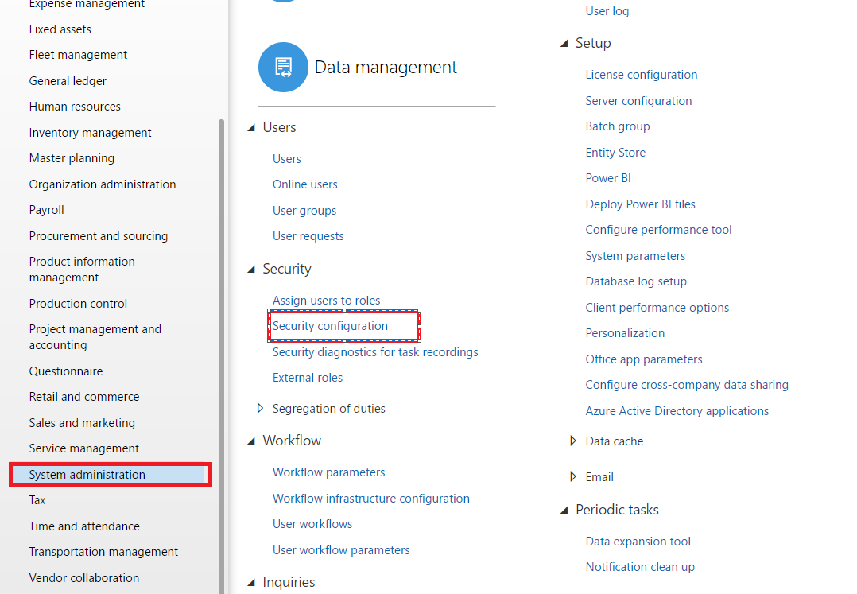

In Security Configuration, you can create a new one or user existing as shown below.

AOT name is the userRoleIdentifier config value

